**Galactic Interactions**

Dylan Johnston & Miles Kopala

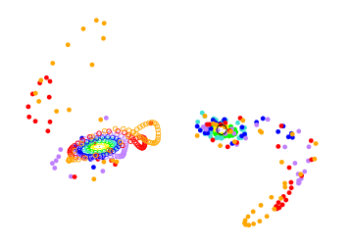

**Abstract**

This paper attempts to demonstrate that various physical features seen in galaxies with a close companion can be attributed to the strong tidal forces exerted during close gravitational interactions. These encounters are recreated using a restricted three body calculation which ignores the self gravitation of the galactic disk, and instead treats the galactic centers as point masses. It is shown that, given an initial set of conditions, the progression of time and the mutual gravitation of two bodies can give rise to a wide variety of galactic substructures, including bridges and tails.

This paper will provide some cursory examples of these interactions on parabolic trajectories, in both 2 dimensions and 3, by considering one of the bodies as a perturbing body and the other as a victim body possessing a spiral disk. Direct passages were found to produce well defined bridge and tail structures, while retrograde encounters were found to leave any prior structure relatively intact. The relative masses of the central bodies were not found to alter the structures produced, but rather scale the degree of these observed features.

**Introduction**

Galaxies are among the most massive objects which we can observe in the night sky. They come in many shapes and sizes: from disk like spiral galaxies to cloud like elliptical galaxies, and a wide variety of shapes in between. They can also be seen to have a number of physical features which can be used to group galaxies into certain sub divisions, the most famous classification system being the model created by Edwin Hubble known as the Hubble sequence or ‘tuning fork’. While many of these physical features are common in certain types of galaxies, such as the bar like structures seen in roughly half of all spiral galaxies, there are even more anomalies which appear to be irregular or even out of place.

Deformations of a galaxy which has a close galactic neighbour or a smaller companion galaxy can be attributed to tidal forces exerted by their mutual gravitation. Tidal forces, which result when the gravitational force exerted on one body by another is not constant, cause different parts of the body to feel that force with varying magnitude. In this paper, we wish to explore the effects if these tidal forces when two bodies come into close gravitational contact. More specifically, we examine the types of physical features that may arise as one galaxy executes a parabolic orbit around a second galaxy possessing a disk like structure. The classic example of modeling this type of encounter was provided by Toomre & Toomre in the December edition of the 1972 Astrophysical Journal. The paper, entitled ‘Galactic Bridges and Tails’, was used as a starting point for our paper, and many of our plots attempt to emulate figures found within.

The astounding variety of physical features which can be observed in situations where galaxies have close gravitational interactions leave any attempt at classifying those features to be quite a difficult task. However, two quite prominent features which can be seeing with varying degree in a wide variety of interacting galaxies are (I) thin, faintly luminous trails of stars which extend behind a galactic centre, generally after a close encounter with an equal or more massive partner, and (II) the bridge-like deformations of a pronounced spiral arm extending towards a nearby, generally smaller, companion in addition to a counter arm that extends on the opposite side of the disk. The interactions which cause these features, as we will show, can greatly distort a galaxy from its initial shape, and in many cases even cause some of the galactic material to be captured by the satellite galaxy or stripped from the disk and flung out into interstellar space. . A relevant example is the current consumption of the Sagittarius Dwarf spheroidal galaxy by the Milky Way. This small satellite galaxy, as it passes through our disk, has the stars and dust comprising its galactic halo ripped off and cast out into the halo of our own galaxy.

The model we will use to simulate these interactions will be based off of a restricted three body problem, with the particles in orbit about each mass behaving as test particles with no gravitational influence on each other, or on the central mass. This is an obvious oversight, as there will most certainly be a quantifiable influence of the disk’s own self mass during an encounter with another massive body. However we will continue with this approach based on the assumption that the attraction generated by the disk will be much smaller than that of the central mass, and thus will not have a drastic effect on our qualitative results.

**Method**

Understanding the basic tidal interactions between two massive bodies can be a complicated process; we began with a simple code which we used and built on in order to create a full model of galactic interactions. We decided to use the Verlet method of integration to calculate any changes in position and velocity. We used this method due to its reliable numerical stability and the property of the method known as time reversibility which was extremely useful in calculating initial conditions.

We began with a simple two body model in two dimensions. The program we created used an inverse square force law in order to determine the force exerted by one particle on the other. The purpose of this prototype model was to create a program that would describe orbits of various eccentricity and, more importantly, parabolic and hyperbolic trajectories. The program accepted user input for the mass of each body, and the initial position and velocity of each body in terms of x and y components. The strength in this model was the amount of freedom it allowed the user in creating any type of orbit desired.

We decided that, once the program was complete, we would create models based on specifically parabolic orbits. This was because, for a given minimum approach distance, and the mass and initial positions of each body, there was only one value for the initial velocities which would achieve a parabolic trajectory. We wanted to stay consistent; keeping the same eccentricity or hyperbolic excess velocity for multiple orbits would be quite challenging when using different initial conditions. While it is still possible to adjust the initial inputs to attain any orbit desired, the purpose of our program is to analyse the various physical features caused by tidal forces during close gravitational interactions, thus we decided to keep the orbit of interaction consistently parabolic.

Once the two dimensional code was operating smoothly, we modified it to include a third dimension and added a centering feature. The centering feature, given the initial positions and velocities of each body, used a subroutine to determine the position and velocity of the system’s center of mass and arranged the bodies so that their closest encounter occurred along the x-axis and the center of mass coincided with the origin. This was beneficial later when outputting plots, as it provided a convenient reference frame without any additional inputs.

With the interaction of two massive bodies successfully modeled, we began considering the galactic disks which would orbit about these massive bodies. Before creating these disks, we designed a comprehensive output subroutine which would be required to create the desired plots. This subroutine was designed to handle several tasks: output the positions of both massive bodies in a single data file, generate a separate data file for each ring, create a file used by gnuplot to plot the data points for a specific moment in time, and generate a bash script which would create the required plot at specified time intervals. Since these objects were dynamic, and we wanted to see how their positions changed over time instead of just lines all over the screen, it needed to do this for every single time step in our program. We made sure to do this first, since particles orbiting the central bodies would be impossible to discern if every data point was on the same plot. It also allowed us to create dynamic movies which played through these motions by looping through the output plots.

With the output completed, we began considering how to create disks about given bodies. We wanted the program to be highly adaptable to many situations determined by user input while remaining fairly intuitive. We constructed the subroutine for implementing these disks to receive the following user input: the ability to choose whether both, one or neither of the bodies had disks, the radial distance of each disk from the central mass as a percentage of the closest approach distance, and the direction of rotation of each disk. The velocity of each star was calculated using yet another subroutine based on how far each ring was from the central mass, and broken into x, y and z components based on the angle of placement around the central mass. We also included a subroutine which linearly scaled the number of stars on each ring as a function of the radial distance of each ring so that the outer rings had more test particles than the inner rings, giving the rings a ‘filled out’ appearance. These rings were then generated about the origin and then translated into position about the central body while their velocities were modified so as to include the velocity of the mass they were orbiting.

The above addition, as well as the output subroutine, was by far the most complicated addition, and required a large amount of trouble shooting before it provided an acceptable output. Several final modifications were included, the two most prominent being the use of padding term for calculating the accelerations of each body and the inclusion of a ‘frame shift’ function. The padding term was included in order to cut the number of calculations required to calculate the proper trajectories of each test particle. As the particle approached one of the larger masses, unless a sufficiently small time step was used, it would be accelerated to a speed much higher than could be accounted for as the particle moved away from the central body. Too many of our test particles were ejected into ‘interstellar space’, so to account for this issue we insured that the magnitude of the distance between the particle and the mass was always kept sufficiently large. We decided to scale this constant as a function of the closest approach distance, and, after a few different values, settled on 4%. The ‘frame shift’ function was used to center the body of interest on the origin and shift the perturbing body to twice its initial distance directly before every output. It used an element of the position array which was otherwise unused, thus we never actually translated any bodies.

There were additional functions we used, but they were mostly just calculation functions which returned a value. The program, at this point, was ready to simulate some interactions.

**Results**

**Basic Examples**

Many of the physical features we can observe in galactic disks can be explained using a few basic examples using a single ‘victim’ galaxy surrounded by a disk and a perturbing galaxy which behaves simply as a point mass. In all six of the following situations, the victim body is positioned at some initial position surrounded by a flat annular disk while the perturbing body is positioned such that the center of mass of the system lies at the origin. Both bodies and the respective test particles are given some initial velocity such that the two central masses will undergo a parabolic encounter. For all six examples, the parabolic trajectory of the perturbing body coincides with the plane of the disk surrounding the victim. All rotation directions are taken with respect to a downwards view on the x-y plane.

The victim body in all six examples has a disk with rings spaced at 20%, 30%, 40%, 50%, 60% and 70% of Rmin. Each ring has number of stars proportional to its radius, 12, 18, 24, 30, 36, and 42 stars respectively, amounting to 162 stars in total.

We chose to scale the gravitational constant to be in terms of Parsecs, years, and Milky Way masses for simplicity. In all examples, the mass of the victim is always one Milky Way mass (1e12) and R­min­ is always 25 kPc. The mass of the perturbing body is equal to the mass of the victim for examples 1 & 2, one third the mass of the victim for examples 3 & 4 and 3 times the mass of the victim for examples 5 & 6.

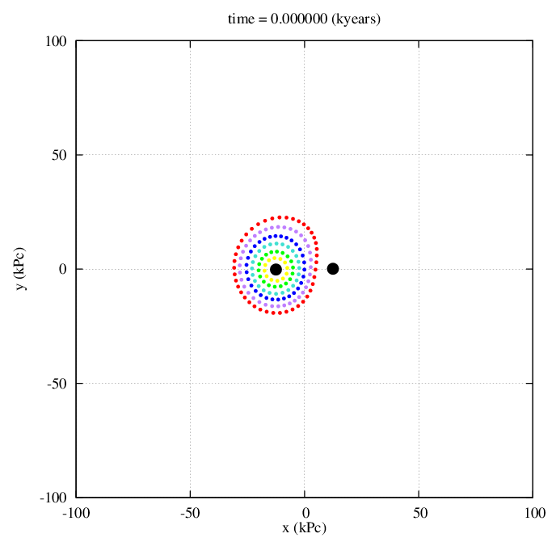The timescale for each passage is in units of kilo years, and begins at a negative value such that the two bodies will be positioned at Rmin at time t = 0. The program then runs for a user determined time, with a total run time of approximately 1 billion years.

Our first example exhibits a retrograde encounter, with the disk of the victim having counter clockwise rotation (Figure 1a). It can be seen that, apart from some stretching within the rings located at 60% and 70% of Rmin (Figure 1b) this encounter is fairly tame. No stars are lost to intergalactic space and the victim body retains its entire disk. The perturbing body does however have a large effect on the angular velocity of the outer disks, causing most of ring 6 and some of ring 5 to build up on the opposite side of the disk in what may appear as a tail (Figure 1c).

Figure 1a) Bodies of equal mass, CCW

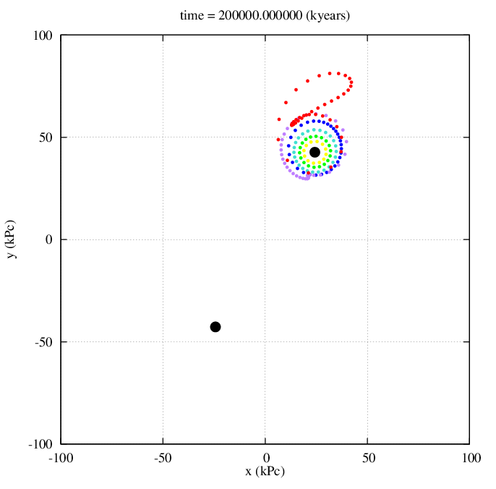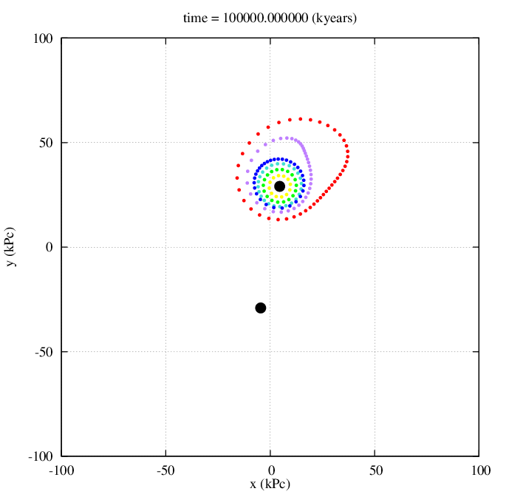

Figure 1) Bodies of equal mass, CCW

(Left = b, Right = c)

In our second example, the disk of the victim has clockwise rotation, which happens to be in the same direction as the perturbing body’s motion. Apart from the material which is ripped off of the victim disk, we can also see that the motion of the perturbing body causes bridge to form for a brief period of time (Figure 2a). However, the counter arm of this bridge is much more distinguished, and after several more times steps the entire extending arm has almost disappeared while the counter arm has extended into a long, narrow tail (Figure 2b). It can be noted that much of the material contained in the initial disk has either been lost to the perturbing mass, or ejected from the system entirely.

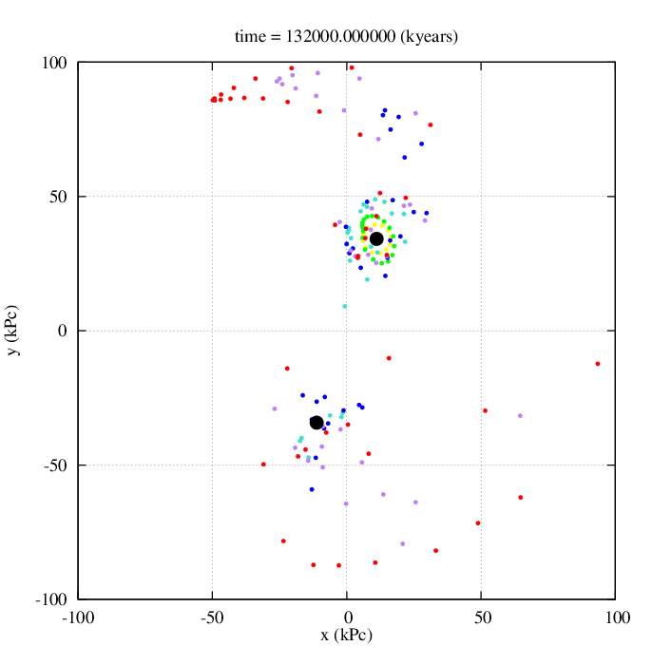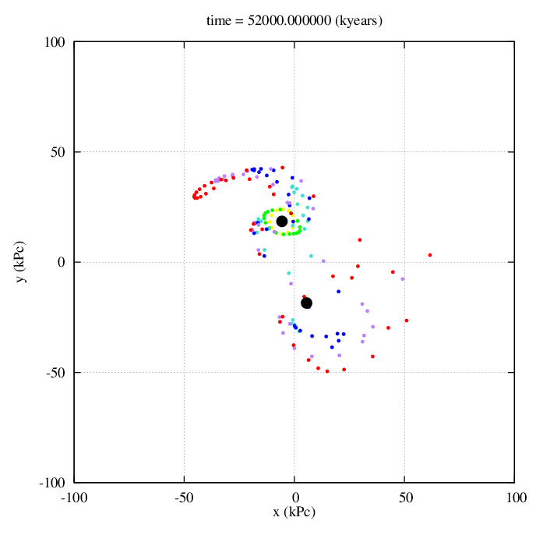

Figure 2) Bodies of equal mass, CW

(Left = a, Right = b)

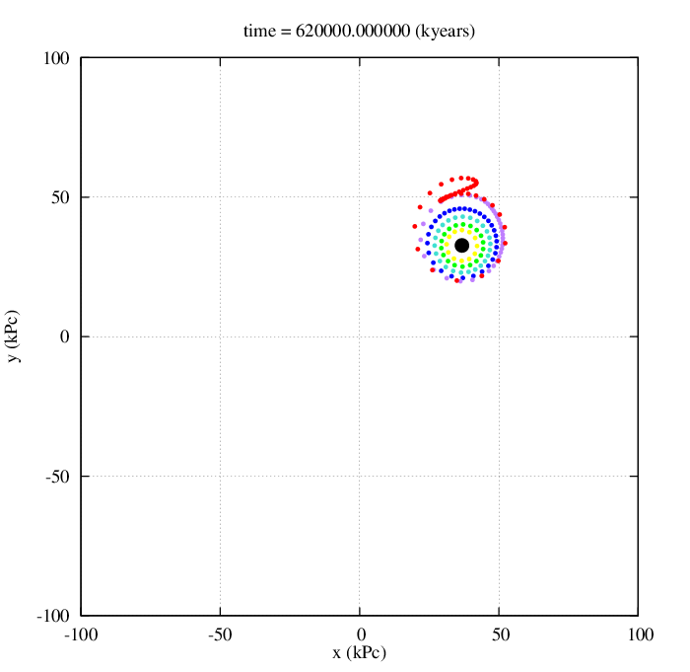For our third and fourth examples, the mass of the perturbing body has been reduced to 1/3 of the mass of the victim body. We first examine a counter clockwise rotation, which ends up being very similar to the first example in this section, with a much less prominent effect on the outer ring oscillations (Figure 3).

Figure 3) Smaller Perturbing Body, CCW

The fourth example is used to demonstrate that smaller companions are often more effective at maintaining a visible bridges between two bodies (Figure 4a). It appears that although it takes longer for this bridge to develop, it lasts longer than the bridge created by the interaction between two equal mass bodies (Figure 4b). While a few particles still escape into ‘intergalactic space’, far fewer are accrued by the perturbing body, which may be the reason behind the longer lasting bridge (Figure 4c). A tail can still be seen on the far side of the victim disk as the perturbing body moves away, more distinguished but not as long lasting as the tail created by the perturbing body with equal mass (Figure 4d).

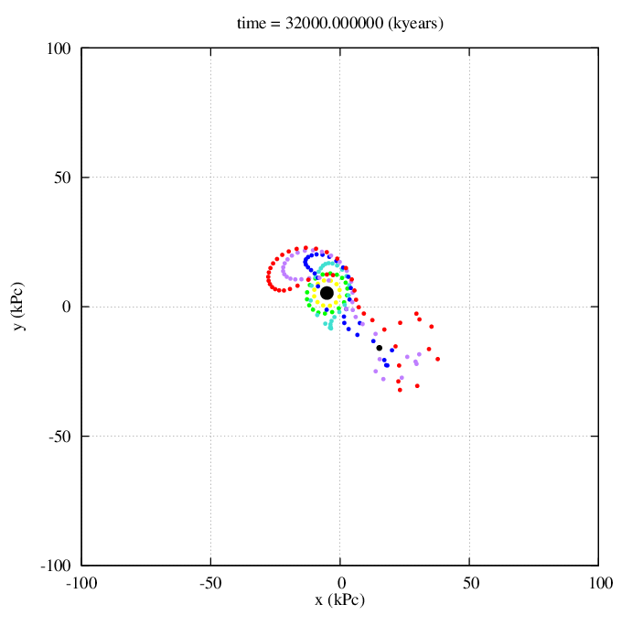 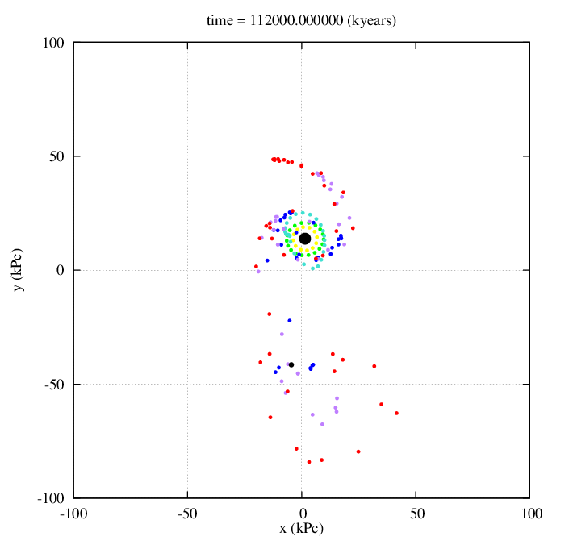

Figure 4) Smaller Perturbing Body, CW

(Left = a, Right = b)

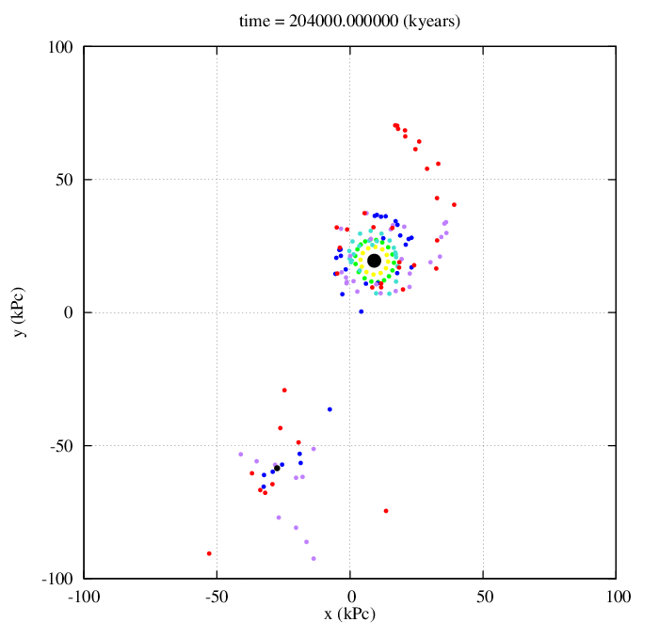 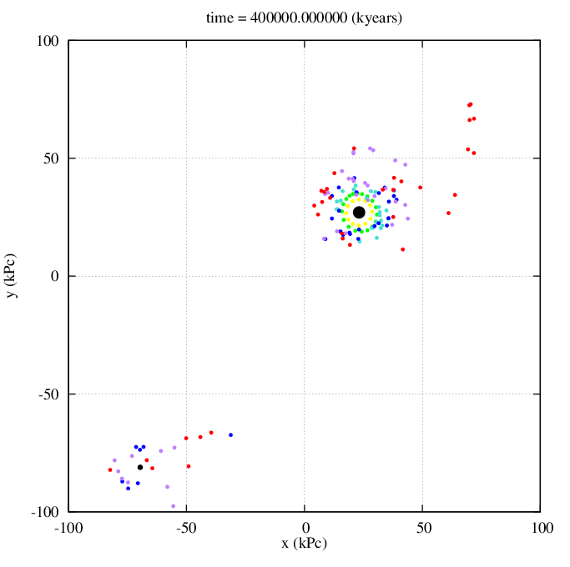

Figure 4) Smaller Perturbing Body, CW

(Left = c, Right = d)

Our fifth and sixth examples contrast the third and fourth examples, in that now the victim body is 1/3 of the mass of the perturbing disk. Had the perturbing body possessed a disk in examples 3 and 4, it might have looked quite similar to this example (Figure 5a). While the fifth example, which has counter clockwise rotation, results in a similar distortion observed in the first and third examples, it is the most distinguished of the three, yielding the greatest asymmetry in the victim disk post interaction and generating the largest of the three tails (Figure 5b).

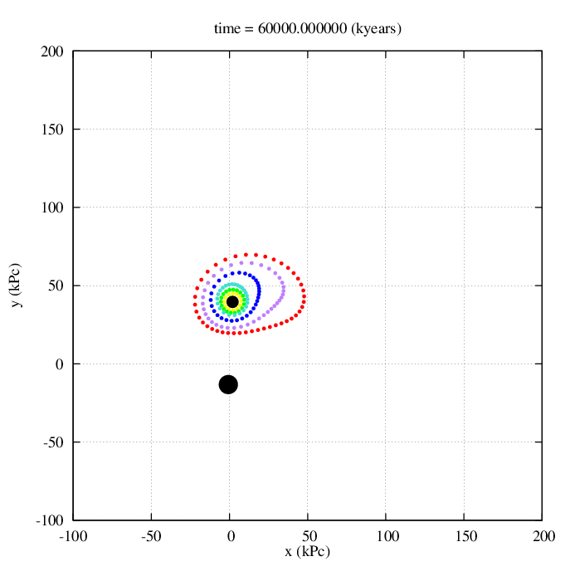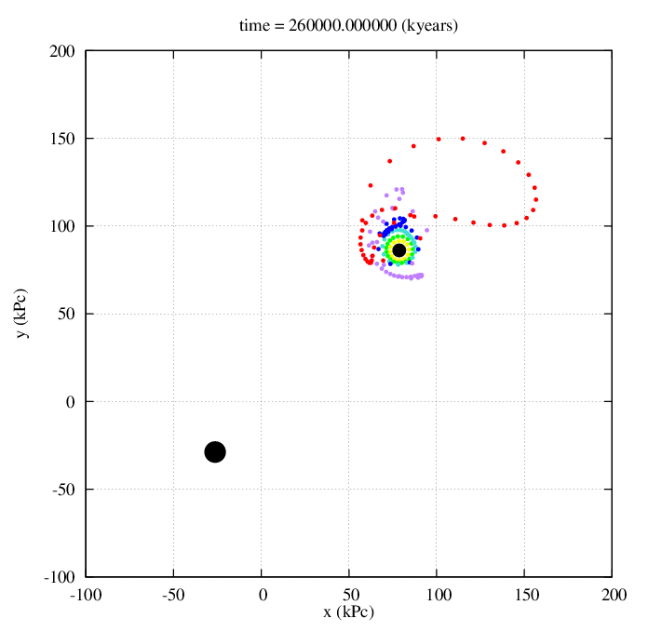

Figure 5) Large Perturbing Body, CCW

(Left = a, Right = b)

Our sixth and final example in this section is by far the most chaotic. This example is again very similar to examples 2 and 4, just accentuated in most respects. The bridge which is created between the two masses is less distinct and shorter lived due to more of the disk being accrued by the larger mass (Figure 6a). More disk material is flung into intergalactic space than the second and fourth examples, while the tail which forms out of the counter arm is much longer and spaced out (Figure 6b).

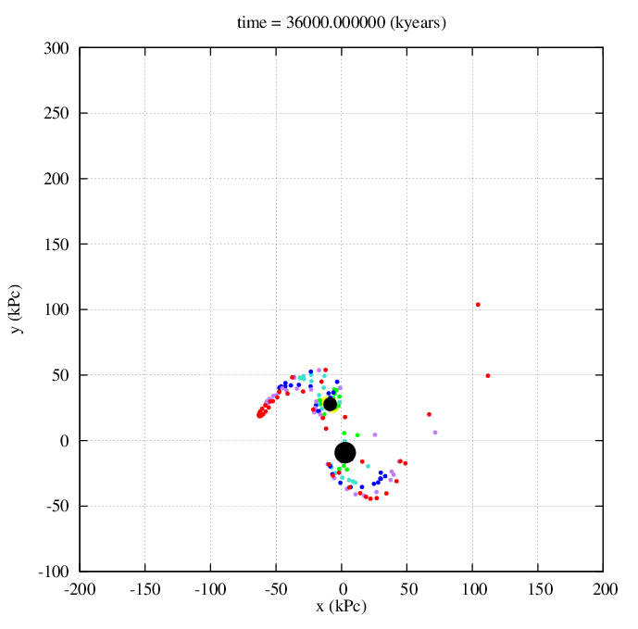 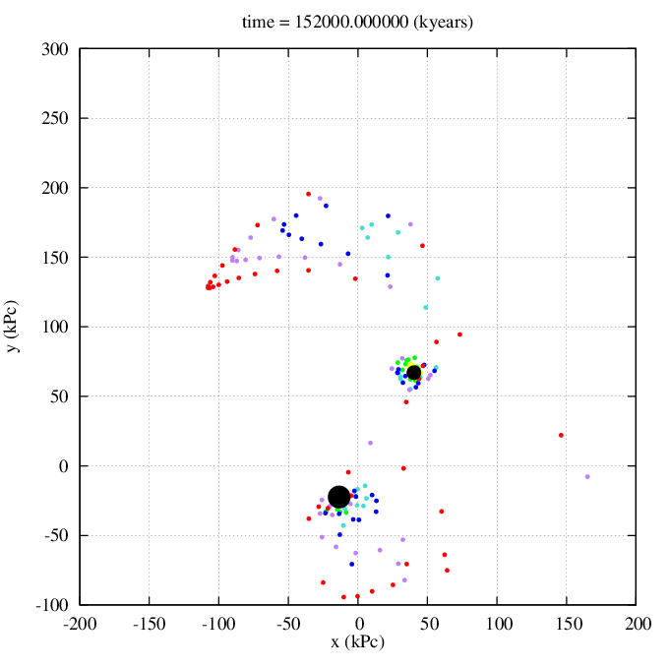

Figure 6) Large Perturbing Body, CW

(Left = a, Right = b)

**3-Dimensional Examples**

We now move on to truly 3-dimensional interactions of a victim mass and a perturbing mass. For all examples in this subsection, the mass of the perturbing body will be equal to that of the victim body; equal to 1 Milky Way Mass. The number of rings has been extended to 7, with equal spacings of 20%, 30%, 40%, 50%, 60%, 70% and 80% of Rmin, which remains at 25 kPc. The seventh ring adds 48 additional stars, for a total of 210 stars in orbit about the victim body.

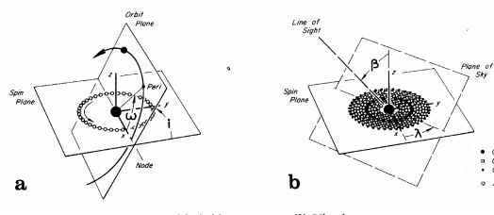To describe the motion of the perturbing body relative to the victim body, we require 2 angles (see Figure 7a): $i$, which denotes the inclination of the orbit of the perturbing body to the spin plane of the victim body, and ω, which denotes the delay between the crossing of the spin plane and the perturbing body’s closest approach to the victim body, namely at Rmin. Two further angles which are used to denote the angles of viewing are λ and β (see Figure 7b). When looking directly down at the x-y plane (with the z axis pointing at you), the angle β denotes the inclination of the z axis, while the angle λ denotes the rotation of the declined angle β about the z axis.

Figure 7

We will consider 3 examples using inclined orbits, although any 3 Dimensional orbit can be calculated using our 3-Dimensional program.

Our first 3-d example has the perturbing body move along a parabolic trajectory in the x-z plane, where Rmin occurs when the perturbing body lies directly above the victim body in the z axis. This corresponds to an Rmin position of $i=90°$ and $ω=90°$. The viewing angles used were $λ=45°$ and $β=60°$.

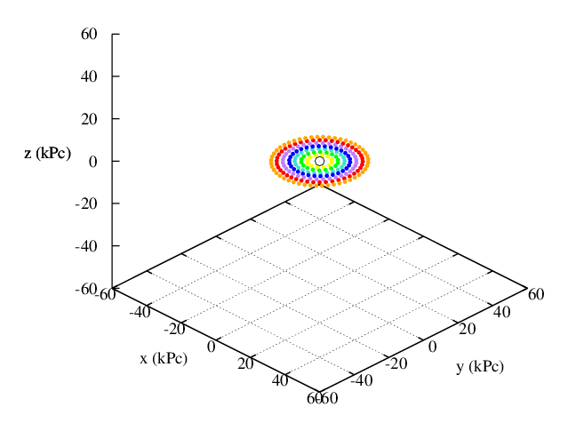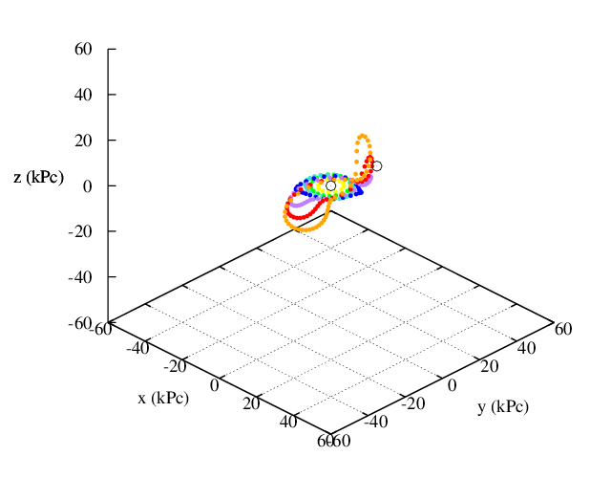

32 million years

-112 million years

152 million years

284 million years

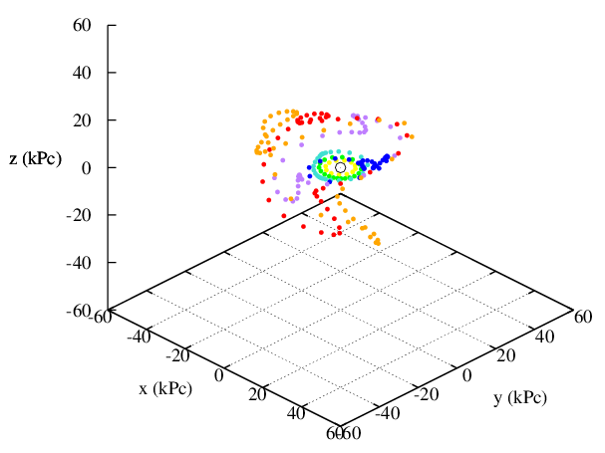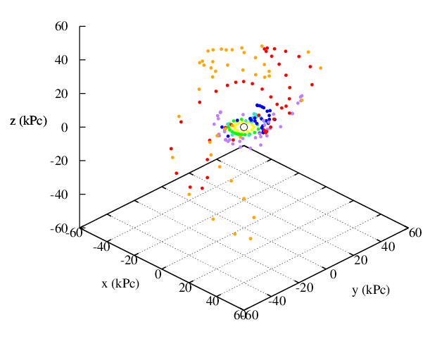

Figure 8) Top Left = a Top Right = b, Bottom Left = c, Bottom Right = d

As the perturbing body approaches the disk, we can see an initial bridge begin to extend upwards in the direction of the mass, while a counter arm begins to form on the opposite side below the disk (Figure 8b). Once the perturbing mass begins away from the victim disk, we see that the outer rings become highly unstable (Figure 8c). Several tails appear to form quite quickly, but then disappear as the stars are ejected perpendicularly to their rotation plane. As time progresses, these tails become less distinguished until the galaxy appears more elliptical than spiral (Figure 8d).

Our second 3-D example involves a trajectory of the perturbing body which causes the perturbing body to reach Rmin in the plane of rotation of the victim body. The viewing angles used were $λ=45°$ and $β=60°$.

48 Million Years

152 million years

0 Years

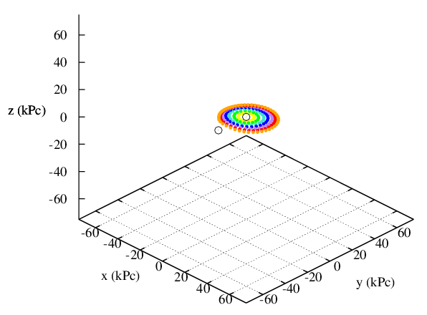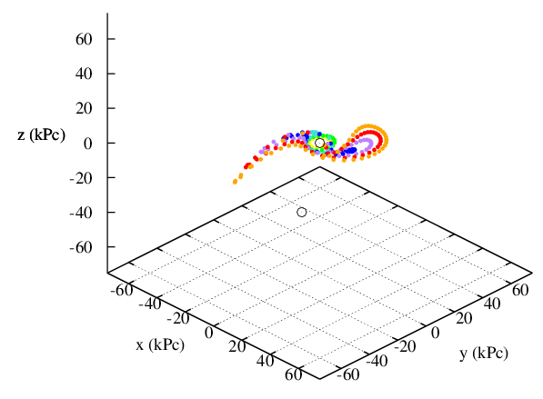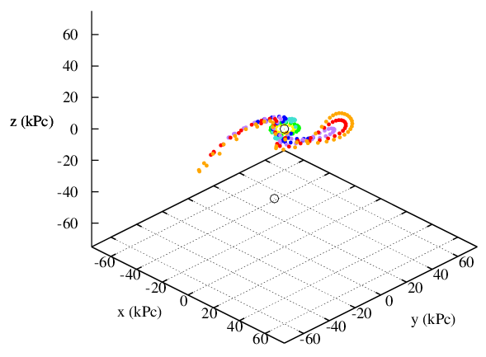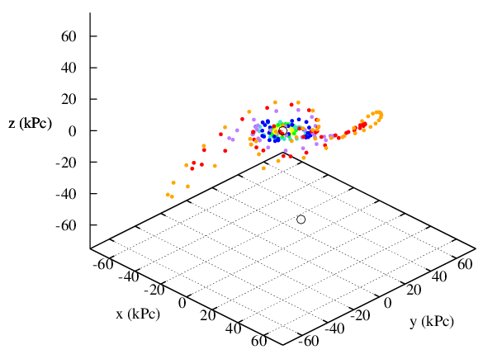

60 Million Years

112 Million Years

Figure 9) Top Left = a Top Right = b, Bottom Left = c, Bottom Right = d

This passage, while in the same axis as the previous trajectory, appears to have a distinct effect on the disk of the victim body, creating two very distinguished arms on either side of the disk (Figure 9b). Rmin occurs at $i=90°$ and $ω=180°$. The bridged arms become very narrow until approximately t = 60 million years (Figure 9c), at which point they diffuse outwards and begin to resemble two increasingly sparse tails (Figure 9d). The dispersion of these two tails appears almost symmetric, unlike any of the interactions we have seen up until now.

Our third and final 3-D example is for an encounter which has the perturbing body pass over top of the victim body such that Rmin occurs at $i=45°$ and $ω=90°$. The viewing angles used were $λ=25°$ and $β=70°$. This interaction seems to remain limited to the outer two most rings. While it appears that any ring with radius less than 60 $°$ was unaffected by this passage (Figure 10a), it can be seen that the outermost rings corresponding to 70% and 80% of R­min­ had a large amount of distortion (Figure 10b). This passage also created a somewhat prominent ‘loop’, however it did so with only the outer most ring, while the other rings simply exhibited some radial and tangential contractions (Figure 10c, 10d).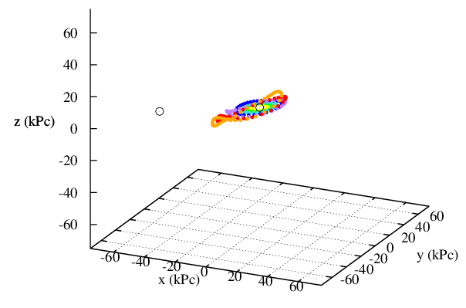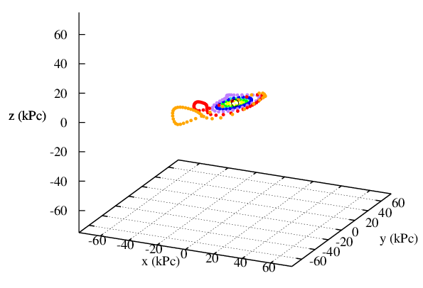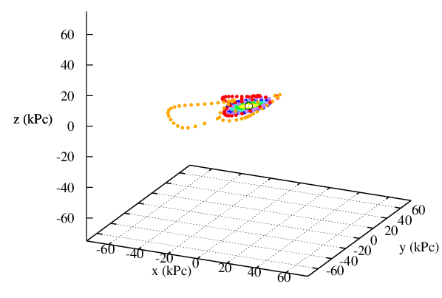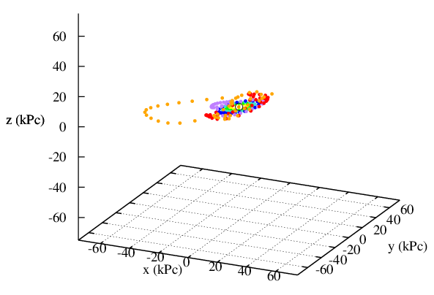

108 Million Years

244 Million Years

340 Million Years

172 Million Years

Figure 10) Top Left = a Top Right = b, Bottom Left = c, Bottom Right = d

**One Final Example**

We decided to include one final example of these interactions in our final report. The final encounter is by far the most interesting example, as it simulates the interactions which occur when both bodies have ring structures in the x-y plane. The position of Rmin is $i=45°$ and $ω=180°$, while the viewing angles used were $λ=25°$ and $β=60°$.

60 Million Years

-100 Million Years

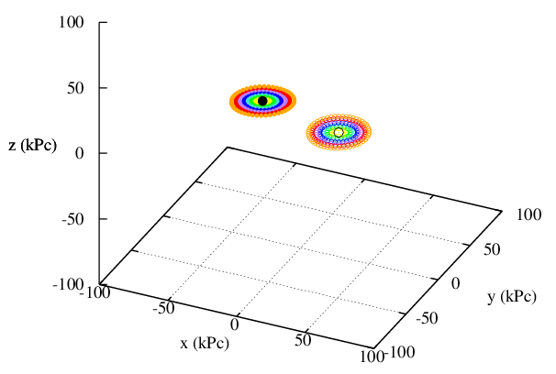 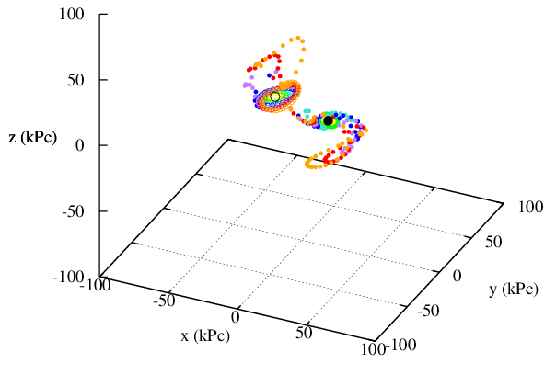

Figure 11) Left = a, Right = b

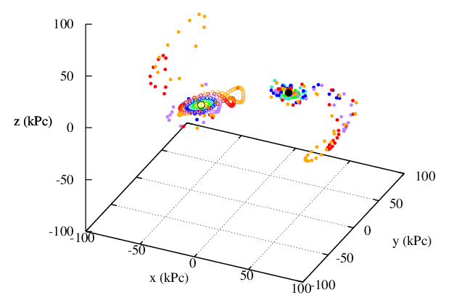

Figure 11c)

144 Million Years

This final graph exhibits the most dynamic variation within a given structure that we have seen. Both galaxies can be seen to begin as spiral disks (Figure 11a) but quickly acquire quite intricate and distinct bridges after just a short amount of interaction (Figure 11b). It should be noted that by the second frame much of the solidly coloured galaxy’s stars are already in orbit about the second galaxy. Both bodies can also be seen to posses quite lengthy tails (Figure 11c) while still retaining their spiral shape.

**Discussion**

While the various we scenarios we considered were limited to two bodies, we have shown that no two interactions are the same, and that even using a restricted three body code we can recreate many different types of bridges and tails caused by the interactions of two central bodies.

Our first, third and fifth examples in 2 dimensions all appear to be similar; varying the mass didn’t have much of an effect on the physical features which were seen to appear after the passage. While the largest of the three bodies interacting in this retrograde motion caused a fairly large ‘loop’ to form on the far side of the disk, as well as a large amount of compression of the various rings themselves, the ring structure still stayed mostly intact long after the perturbing mass had left the vicinity, indicating that this type of interaction was not the most effective at generating the desired bridges and tails.

The second, fourth, and fifth examples, all examples of a gravitational encounter which had the rotation of the disks coincide with the direction of motion of the perturbing body, created a distinct tails and bridges. The size of the tail which was created from the counter arm seemed to be inversely correlated to the duration of an observable forward arm. While the largest mass caused the longest and most spread out tail at the end of the simulation, it was too massive to create an observable forward arm for longer than a few time steps. Conversely, while the smallest mass caused the disk to have a distinctly smaller tail upon simulation completion, it had a much more distinguished bridge structure when still in the same vicinity as victim disk, and this bridge structure was obviously visible for much longer than the other two cases. The scenario with equal masses was sort of an intermediate, although it should be noted that it ejected far less disk material into ‘intergalactic space’. The direct passage of two galaxies appeared to quite distinctly create the bridges and tails which we were attempting to recreate.

Our three dimensional examples exhibited much more interesting behaviour during their interactions than their two dimensional counterparts. Example number 2 gave both forward and counter arms which appeared to be almost symmetric to each other, and that held their shape for a very long period of time. Example 1 was particularly interesting because it showed some of the chaos which can arise from these interactions, causing a spiraling disk to end up almost elliptical in appearance. Example 3, while less exciting than the other two examples, demonstrated that the tidal forces encountered in this paper are so extreme that they can cause just a single ring to extend out as a tail while leaving the rest of the rings more or less intact around the galactic nucleus.

The final example which describes two bodies, each possessing a disk, as they interact on a parabolic orbit demonstrates just how rich this problem is. For just one given set of initial conditions, we can see that these objects can begin in a perfectly spiral shape, develop large arms and counter arms, and settle into smaller disks with long and intricate tails. This example clearly demonstrates that the tails and bridges observed in galaxies which have a close neighbour can be directly attributed to the tidal forces exerted on one another.

**Conclusion**

A restricted three body code was designed to demonstrate that the various bridges and tails which can be seen as features of galaxies with close neighbours can be attributed to gravitational tidal forces. The physical features which were generated by this program show that using a simple model, we can create some similar features to those seen in various galaxies using just the interaction of gravity.

**References**

*Galactic Bridges & Tails* - Toomre, A and Toomre, J, *The Astrophysical Journal 178:623-666.* December 15, 1972.

*Computational Physics 2E* - Giordano, N. and Nakanishi, H. Published 2006.

en.m.wikipedia.org/wiki/Parabolic_trajectory - Wikipedia page concerning parabolic Trajectory calculations, accessed November 2014.

Class Notes – Computational Methods in Physics. Instructor: Dr. M. Duncan.